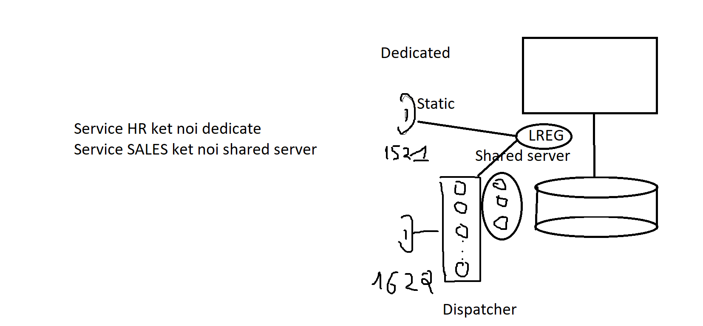

1/ Tạo them listener LISTENER1 port 1622

[oracle@localhost ~]$ . oraenv

ORACLE_SID = [oracle] ? orclcdb

The Oracle base has been set to /u01/app/oracle

[oracle@localhost ~]$ vi $ORACLE_HOME/network/admin/listener.ora

--Thêm các dòng sau vào cuối file

LISTENER1 =

(DESCRIPTION_LIST =

(DESCRIPTION =

(ADDRESS = (PROTOCOL = TCP)(HOST = localhost)(PORT = 1622))

)

)

--Sau đó start listener1

[oracle@localhost ~]$ lsnrctl start listener1

LSNRCTL for Linux: Version 19.0.0.0.0 - Production on 28-DEC-2022 08:29:03

Copyright (c) 1991, 2019, Oracle. All rights reserved.

Starting /u01/app/oracle/product/19.0.0/dbhome_1/bin/tnslsnr: please wait...

TNSLSNR for Linux: Version 19.0.0.0.0 - Production

System parameter file is /u01/app/oracle/product/19.0.0/dbhome_1/network/admin/listener.ora

Log messages written to /u01/app/oracle/diag/tnslsnr/localhost/listener1/alert/log.xml

Listening on: (DESCRIPTION=(ADDRESS=(PROTOCOL=tcp)(HOST=localhost)(PORT=1622)))

Connecting to (DESCRIPTION=(ADDRESS=(PROTOCOL=TCP)(HOST=localhost)(PORT=1622)))

STATUS of the LISTENER

------------------------

Alias listener1

Version TNSLSNR for Linux: Version 19.0.0.0.0 - Production

Start Date 28-DEC-2022 08:29:03

Uptime 0 days 0 hr. 0 min. 0 sec

Trace Level off

Security ON: Local OS Authentication

SNMP OFF

Listener Parameter File /u01/app/oracle/product/19.0.0/dbhome_1/network/admin/listener.ora

Listener Log File /u01/app/oracle/diag/tnslsnr/localhost/listener1/alert/log.xml

Listening Endpoints Summary...

(DESCRIPTION=(ADDRESS=(PROTOCOL=tcp)(HOST=localhost)(PORT=1622)))

The listener supports no services

The command completed successfully

--Tạo service SALES

SQL> conn / as sysdba

Connected.

SQL> exec dbms_service.create_service('sales','sales');

SQL> exec dbms_service.start_service('sales');

--Set thông số local_listener

alter system set local_listener= '(ADDRESS=(PROTOCOL=tcp)(HOST=localhost)(PORT=1622)),(ADDRESS=(PROTOCOL=tcp)(HOST=localhost)(PORT=1521))';

--Thong so dispatcher

alter system set dispatchers= '(SERVICE=sales)(ADDRESS=(PROTOCOL=TCP)(HOST=localhost)(PORT=1622))(DISPATCHERS=3)';

--Thông số share server

alter system set shared_servers=3;

--Register với các listener

SQL> alter system register;

--Kết nối qua service sales

SQL> conn system/oracle@localhost:1622/sales

Connected.

--Ở một session khác voi SYS kiểm tra:

SQL> select server from v$session where username='SYSTEM';

SERVER

---------

NONE

--Tao service HR

SQL> conn / as sysdba

Connected.

SQL> exec dbms_service.create_service('HR','HR');

PL/SQL procedure successfully completed.

SQL> exec dbms_service.start_service('HR');

PL/SQL procedure successfully completed.

--Mặc định các kết nối qua service HR la dedicate tuy nhiên có thể set trong file tnsnames.ora như sau:

HR =

(DESCRIPTION =

(ADDRESS_LIST=

(ADDRESS = (PROTOCOL = TCP)(HOST = localhost)(PORT = 1622))

(ADDRESS = (PROTOCOL = TCP)(HOST = localhost)(PORT = 1521))

)

(CONNECT_DATA =

(SERVER = DEDICATED)

(SERVICE_NAME = hr)

)

)

--Thuc hanh cau hinh listener tĩnh (khai bao thông tin instance cho listener)

Thêm vao file listener.ora cac dong sau:

SID_LIST_LISTENER=

(SID_LIST=

(SID_DESC=

(GLOBAL_DBNAME=orclcdb)

(SID_NAME=orclcdb)

(ORACLE_HOME=/u01/app/oracle/product/19.0.0/dbhome_1)

)

)

SID_LIST_LISTENER1=

(SID_LIST=

(SID_DESC=

(GLOBAL_DBNAME=orclcdb)

(SID_NAME=orclcdb)

(ORACLE_HOME=/u01/app/oracle/product/19.0.0/dbhome_1)

)

)

--Sau đó dùng các lệnh sau để stop, start listener

Lsnrctl stop listener

Lsnrctl stop listener1

Lsnrctl start listener

Lsnrctl start listener1

__ Học viên tham khảo các file listener.ora va tnsnames.ora đính kèm